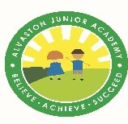
Date: 15th October 2021 Year Group: 3
English:  Last week we acted out the brilliant book, ‘How to Wash a Woolly Mammoth’. It is an instructions book and we have enjoyed putting the instructions in order. Now we are going to make delicious rock cakes and use what we have learned about instructions to write our own instructions to make rock cakes. | Maths:  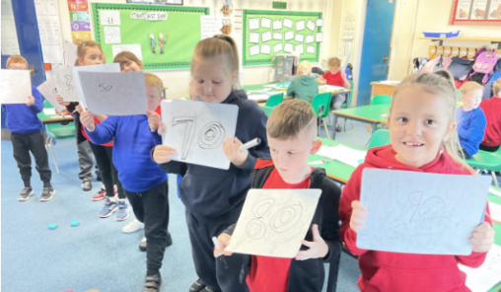  This week we have worked on addition skills. In arithmetic starters, we have recalled addition facts to 10 and, 20 and used these to solve other calculations. We have also began to learn column addition.
In our Stone Age to Iron Age topic, we have moved onto finding out about the Bronze Age. We looked at evidence found in graves and used it to find out how some people became skilled craftspeople. | If your child is isolating, please encourage them to read as much as possible, go on TT Rockstars and Purple Mash, and practise their spellings on Spelling Shed.  Almost all children have now taken their ipads home. If you have not returned the user agreement, please do so as soon as possible, so that your child can bring their ipad home.
If you have not yet paid for the Stone Age Day, please could you pay on Parent Pay. Thank you to all of the parents who have contributed. We are all really excited about taking part on Tuesday or Wednesday (3F and 3WB on Tuesday, and 3H on Wednesday).

