Alvaston Junior Academy

OUR APPROACH TO REMOTE LEARNING
2020-2021

Remote Learning Strategy – Alvaston Junior Academy 2020/21
Context
At Alvaston Junior Academy (AJA), we recognise the importance of remote learning. This is particularly important during the current COVID-19 pandemic. Self-isolation and bubble closures are likely to continue in the short to medium term and it is imperative that all children are able to access the curriculum that their peers in class and year group are accessing. Importantly, it is essential that we do all we can to ensure that no child falls behind in their learning as a result of working from home. This particularly applies to children in receipt of pupil premium funding and those without access to the internet. We are also mindful of the great importance of the wellbeing and the mental health of all children and their families during this period of increased isolation and stress. As a result of all of this, we have decided to formalise the process for remote learning so that it is consistent and easily understood by all stakeholders.
Pupil voice on Remote Learning in Summer 2020
During the summer term 2020, we were able to successfully provide remote learning via Purple Mash; through the provision of paper based learning packs hand delivered to pupils’ homes and beingavailable for collection from school. Additionally, children were able to access TT Rock Stars during this period. For those pupils working from home, we provided a weekly timetable of Remote Learning expectations via both our school website and class dojo, which ensured that pupils were clear about the work expectations. In addition, for the final 7 weeks of the summer term, we were able to safely educate 5 bubbles of 10 Year 6 pupils on the school site alongside 5 further bubbles of vulnerable and key worker children. This enabled us to provide a curriculum using a combination of in class and remote learning strategies.
These foundations, together with feedback from the summer term 2020, have allowed us to build a remote learning strategy which meets the needs of the children at AJA based upon staff, pupil and parent views and experiences.
Resources available for Remote Learning
We have a wide range of platforms available for home learning which are as follows:
- Purple Mash
- Accelerated Reader (reading quizzes)
- myON (Online reading books linked to Accelerated Reader quizzes)
- Times Tables Rockstars
- Videos and worksheets via class dojo
- Spelling Shed
- Oak Academy
Wellbeing within the Remote Learning Curriculum
The wellbeing of our pupils is of utmost importance, particularly when pupils are working from home and have limited opportunities to communicate with their peers. As part of the Purple Mash website, children receive personalised feedback from their teachers with encouragement, praise and next steps where applicable. Teacher will contact all pupils to check on well-being and to keep children feeling connected to the school.
Safeguarding within the Remote Curriculum
Contact will be made with families via phone. The frequency of phone calls will depend on the length of isolation and level of need. A record of these calls will be kept on Share Point in an appropriate file and access given to all DSL and Deputy DSLs (KSL, KP). All pupils will be contacted by the class teacher at least once a week if there is a bubble closure for 14 days. A record of all phone calls will be maintained by the class teacher and shared (via Share Point) with the Principal, Deputy Principal, year group leads, safeguarding and family support manager and SENDCO as necessary. Any concerns must be noted on ‘CPOMS’ in line with academy policy.
Communication
At AJA we realise that effective communication is the key to working successfully with both pupils and parents. We have worked hard to develop a range of communication methods so that we can easily keep in touch with parents when children are working from home.
- Dojo messenger (1:1 messages to parents and whole class update/message)
- Dojo portfolio (to share individualised positives)
- Dojo class story updates
- Pre-recorded videos from staff shared via dojo/text
- Emails
- Weekly learning logs to make tasks and expectations clear and help children and parents to organise and timetable their day
- Phone calls (this is dependent upon the isolation time e.g. 14 day isolation = at least two phone calls, safeguarding concerns = regular phone calls dependent upon stage of support, offer of food parcel for FSM pupils = phone call at start of isolation)
- Individualised feedback provided via Purple Mash
- Clear task instructions on Purple Mash
- Whole school newsletters

Remote learning: making the best use of teaching assistants to:
- support pupils and the class teacher who are at home whilst they themselves are still in school, and
- support pupils and the class teacher whilst having to self-isolate/work from home themselves due to bubble closures/track and trace contact:

  - After having training on Purple Mash (Autumn 2) TAs can support teachers in allocating activities, monitoring engagement, marking and giving feedback
  - Recording themselves reading books/chapters for children to access.
  - Making welfare phone calls
  - After having training on TT Rock Stars (Autumn 2) TAs can monitor and set ‘battles’ on TT Rockstars
  - Taking part in TT Rockstars challenges with pupils
  - Finding resources for the following week’s learning
  - Being available for given time slots for ‘live’ Q&A sessions with pupils via email on Purple Mash

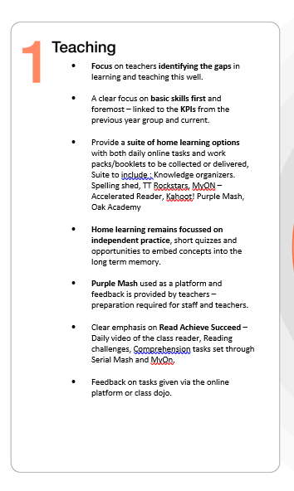
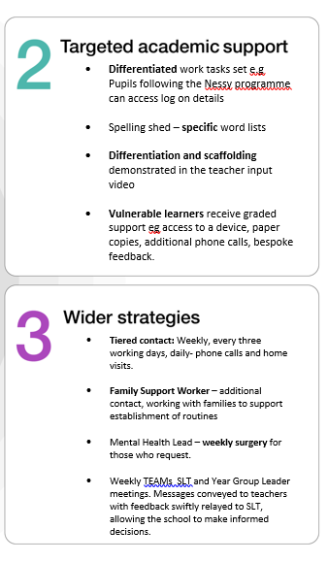

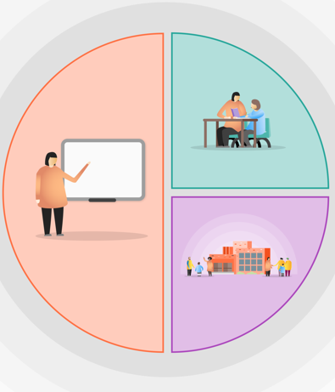

Teacher preparation
Remote Learning for Short Term Absences (e.g. awaiting test results)

- Purple Mash – Daily 2dos set for Maths and English based on learning in class and current level of attainment
- Purple Mash—Daily 2dos set for Science/Art/DT/Geography/History
- Spelling Shed word list set and Nessy
- Clear emphasis on Read, Achieve, Succeed – children to spend at least 20 minutes per day reading on Myon, complete Accelerated Reader quizzes upon book completion
- Daily Times Tables Rockstars and Spelling shed activities
- Daily physical tasks
• Paper work packs to be provided for those who do not have internet/device access current learning for those days

1. At least one well being phone call to be made by class teacher (including speaking to a child) if the isolation period is longer than 7 days (where there is additional safeguarding monitoring, contact DSL/Deputy DSL for support on additional check– ins). Phone call to be logged on One Drive Sharepoint document and shared with Principal, Deputy Principal, Assistant Principal, Year Group Lead and Family Support Worker. (KSL, KP, CP, YGL, TD)
2. Teacher to liaise with parents through dojo messenger where applicable
3. Purple mash feedback to be provided for all work completed (Class teacher)
4. Class teacher to keep RAG rated running document of work completed and to liaise with families where work is incomplete. Document to be logged on One Drive Sharepoint and shared with Principal, Deputy Principal, Assistant Principal, Year Group Lead and Family Support Worker. (KSL KP CP YGL TD)
5.

Message from the office to say child is off– awaiting test results

Teacher to message parent on Dojo and direct them to the Purple Mash

Child cannot access online– paper text and TTR to be sent out
Remote Learning for Long term Absences Due to Isolation of Family Member
Teacher preparation
• Purple Mash – Daily 2dos set for Maths and English based on learning in class and current level of attainment
• Purple Mash—Daily 2dos set for Science/Art/DT/Geography/History
- Spelling Shed word list set and Nessy
- Clear emphasis on Read, Achieve, Succeed – children to spend at least 20 minutes per day reading on Myon, complete Accelerated Reader quizzes upon book completion
- Daily Times Tables Rockstars and Spelling shed activities
- Daily physical tasks
- A home learning book will be provided for those who do not have internet/device access

• Home learning book: Two weeks’ worth of learning based on that Year group maths, reading, spelling, punctuation and grammar, and well-being

1. At least one well being phone call to be made by class teacher (including speaking to a child) if the isolation period is longer than 7 days (where there is additional safeguarding monitoring, contact DSL/Deputy DSL for support on additional check– ins). Phone call to be logged on One Drive Sharepoint document and shared with Principal, Deputy Principal, Assistant Principal, Year Group Lead and Family Support Worker. (KSL, KP, CP, YGL, TD)
2. Teacher to liaise with parents through dojo messenger where applicable
3. Purple mash feedback to be provided for all work completed (Class teacher)
4. Class teacher to keep RAG rated running document of work completed and to liaise with families where work is incomplete. Document to be logged on One Drive Sharepoint and shared with Principal, Deputy Principal, Assistant Principal, Year Group Lead and Family Support Worker. (KSL KP CP YGL TD)
5.

Message from the office to say child is Isolating due to family member

Teacher to message parent on Dojo and explain tasks (see teacher preparation)

Home learning book ALSO sent out
Remote Learning for Long term Absences Due to Bubble Closure
Teacher preparation
- Differentiated Purple Mash – Daily 2dos set for Maths and English based on learning in class and current level of attainment
- Clear emphasis on Read, Achieve, Succeed – children to spend at least 20 minutes per day reading on Myon, complete Accelerated Reader quizzes upon book completion—Upload shared reading text and vipers questions to Purple Mash Class Blog
- Maths resource Mat (digital and paper version) to cover a number of aspects
- Daily Times Tables Rockstars and Spelling shed activities
- Daily physical tasks
- Home learning book to be provided for every child—including comprehension/arithmetic/well being tasks/spelling, grammar and punctuation
- Knowledge organisers to be provided for every child to read and ‘grow’ background knowledge. Kahoot quiz prepared linked to knowledge organizer

1. Teacher to send daily whole class video message via dojo to keep children motivated and signpost to Home Learning Book task (Possible Teams meetings following trial /Pilot project—to take the register)
2. At least one well-being phone call to be made by class teacher (including speaking to a child) if the isolation period is longer than 7 days (where there is additional safeguarding monitoring, contact DSL/Deputy DSL for support on additional check– ins). Phone call to be logged on One Drive Sharepoint document and shared with Principal, Deputy Principal, Assistant Principal, Year Group Lead and Family Support Worker. (KSL KP CP YGL TD)
3. Teacher to liaise with parents through dojo messenger where applicable
4. Purple mash daily feedback to be provided for all work completed (Class teacher)
5. Class teacher to keep RAG rated running document of work completed and to liaise with families where work is incomplete. Document to be logged on One Drive Sharepoint and shared with Principal, Deputy Principal, Assistant Principal, Year Group Lead and Family Support Worker. (KSL, KP, CP, YGL, TD)
* to be updated with TA role by the end of Autumn Term 2

Teacher to message all parents on Dojo to inform that daily lessons will go live at 9am
Tasks will be set for that day and feedback given at the end of the day, ready for the next day’s learning
Day 1 teacher sets expectations for the week

