Week Beginning 27th April 2020
Year 3 Home Learning Overview

Purple Mash | Maths, computing and topic tasks have been set as ‘To dos’  Maths: Focus – Fractions – finding missing patterns  Computing: Focus – Coding. Using Fun with Fish TIP: Use the videos and hint section if you get stuck!  Topic: Focus - Plants: plant labelling activity  Extension: Focus – Grammar & Punctuation: The Fox and the Hen/Spelling - homophones  Daily Times Tables: Don’t forget your Times Tables Rock Star work as well!  Please remember to try your best and have a go at the activities. Please don’t feel pressured or anxious about completing all tasks as we are well aware that home-life does not look the same in every house.
Class Dojo | Well-being Task  Meditation  Sit somewhere quiet and imagine yourself somewhere relaxing in your imaginary country. Maybe it has got a beach made from fluffy marshmallows, creating a soft bed for you. Maybe you are in a beautiful garden, with golden spring.  Creative Task:  Design an imaginary country  Draw, write or make an imaginary country. Think about where in the world it is. Label it or describe it.  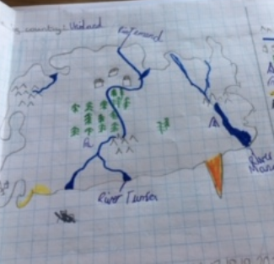
Reading | Challenge:  Phone/FaceTime/Zoom someone and read a story to them. I would FaceTime my wife. Read a comic. Or a graphic novel. Read about how to look after your wellbeing during the Covid-19 shutdown. There are lots of ideas online.  Read a book in a home-made den. Don’t get into trouble – ask first! This is you reading challenge for this week. As you can see – there are 8 challenges. See how many you can complete and let us know how you get on. Read some funny poems. Roald Dahl’s ‘Revolting Rhymes’ are a good start.  Read something online about a famous person you admire. I would research The Queen. Read First News or a different newspaper. You can do this online if you don’t have one in the house. Read about one or more of the politicians you see on the daily briefings. Turn BBC1 on at 5pm for this.

