Working from home Year Group overview
Year Group: 4
Week Beginning: 15.6.2020
Overview:
Teacher to plan: | Focus: | Task: | Deadline: | To be marked- yes or no
Mrs Boerder | Maths | Times tables  This is Multiplication 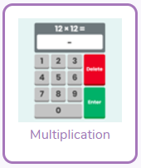  Maths: Focus – Time  This week we are learning about the 12 and 24 hr clocks. You will find it useful to watch this before you begin..  https://www.bbc.co.uk/bitesize/topics/zkfycdm/articles/zcrmqty  First try this to practice changing between 12 and 24 hr clocks....  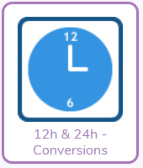  Then put it into practice with these quizzes….  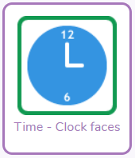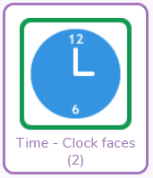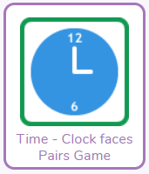 | Friday 19th June | Brief comment/  symbol
 | Topic | Purple Mash -  Romans:  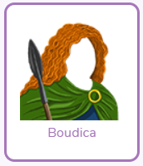2do- Use the mashcam to turn yourself into Boudicca and explain why you attacked the Romans.  This video might help  https://www.youtube.com/watch?v=ZKqx7lvlQK0  Mrs Boerder had a go but I’m sure you can do better!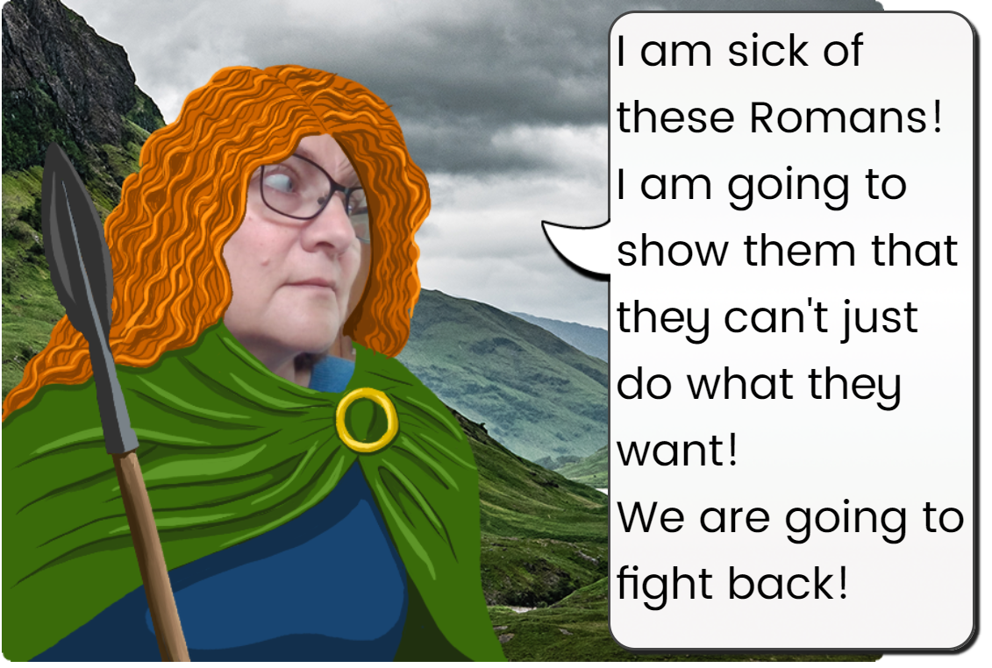  Science:  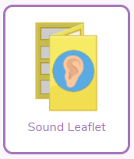 2do- Use what you have learnt about sound to create a leaflet. You can watch the slideshow again to help you. | Friday 19th June | Yes
 | Computing | Purple Mash – Coding,  Guard the castle (Chimp) - Help the night guard the castle  Night and day (Gibbon)– Use variables, timers, and if statements to loop between night and day scenes. | Friday 19th June | Brief comment/  symbol
Mr Findlater | Well Being - DOJO | ﷟HYPERLINK "https://www.youtube.com/watch?v=R-BS87NTV5I"Pebble Path of positivity  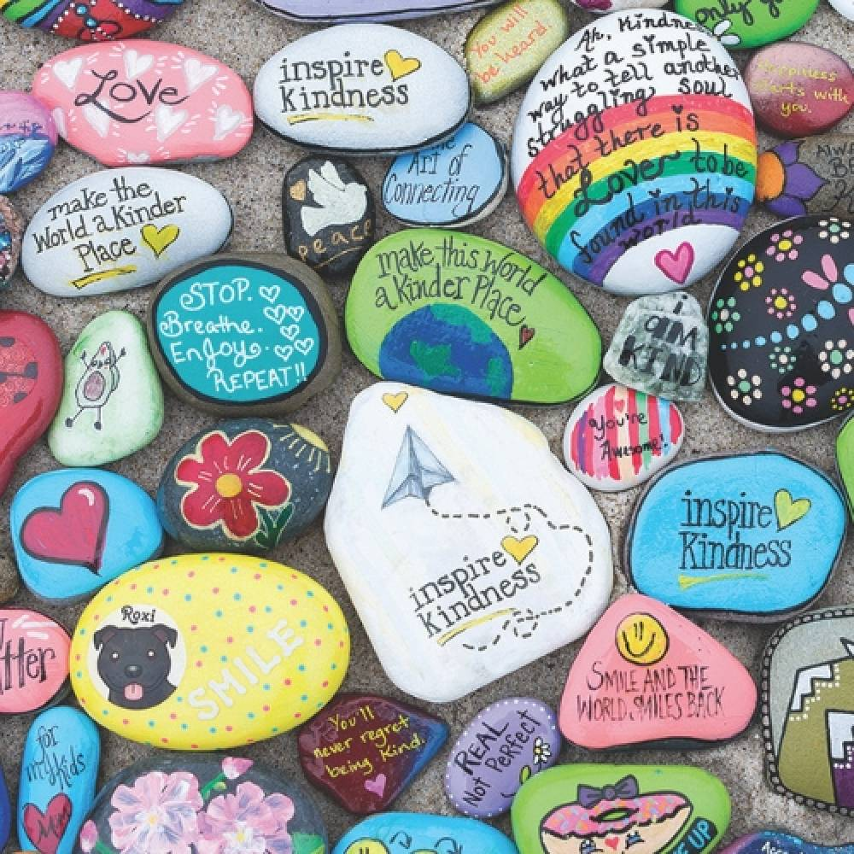  - Paint/ decorate your own pebble  - You can bring your pebble to school and place it outside the school with other children’s pebbles  - This will create a path of positivity into school.  - Design your pebble any way you want – using any colours or styles of decoration.  Send a picture to your teacher | Chn not expected to spend more than 1 hour on this. | No- but children are encouraged to share a photograph with their teacher.
 | Creative Task - DOJO | 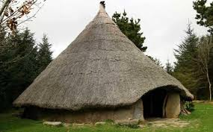  Create your own Celtic Roundhouse  These video shows you what they were like https://www.bbc.co.uk/bitesize/clips/zqxtsbk  - The Celts lived in roundhouses before the Romans arrived  - Do the reading activity on roundhouses below first  - You can try to make one with twigs and things found in your garden  - If you don’t have any materials you could make a paper one  Send your teacher a picture! | Chn not expected to spend more than 1 hour on this. | No- but children are encouraged to share a video with their teacher.
Joint | Reading Focus: Prepare a ‘reading challenge/interesting task or competition for the week.  Read an extract/story and upload to dojo.  Signpost to read First News weekly | Challenge:  Chapter 4 of these books has been set as a 2do. Choose one to read. Emerald Sapphire Treasure’s Island A Horde of Ravens Complete the online multiple-choice quiz for your chosen book. Read First News or a different newspaper. You can do this online if you don’t have one in the house.  Listen and read along to the story Krindlekrax, read by Mr Findlater on Flipgrid. Can you go through the first 3 chapters? Access the story here: https://flipgrid.com/98c4e191 Password: Storytime The reading challenges have changed slightly this week! The first 2 have been set as 2dos on Purple Mash, which means that we would like you to make sure you have completed them. You can then see how many of the other challenges you can complete. Read this non fiction article on Celtic Roundhouses http://www.primaryhomeworkhelp.co.uk/celts/index.html Follow these instructions on how they made them http://www.bbc.co.uk/history/interactive/animations/ironage_roundhouse/index.shtml  After you have listened to Krindlekrax make a prediction of what you think will happen next in the story. What will happen to Ruskin? What will Elvis do? Any other things you think will happen? Vocabulary is very important! If there are any words in Krindlekrax that you do not know, pause the video and look them up in a dictionary or online. Write each word in a new sentence Use this link to have a go at the BBC Bitesize daily lesson on summarising: https://www.bbc.co.uk/bitesize/articles/zr93bdm The poems are about funny things that happen at school – I love reading these! | Ongoing through the week. | Some- the first 2 brief comment or symbol –children should be encouraged to respond to the other challenges via dojo.

Purple Mash | Maths, computing and topic tasks have been set as ‘To dos’  Maths: Focus – Time  This week we are learning about the 12 and 24 hr clocks. You will find it useful to watch this before you begin..  https://www.bbc.co.uk/bitesize/topics/zkfycdm/articles/zcrmqty  First try this to practice changing between 12 and 24 hr clocks....  Then put it into practice with these quizzes….  Coding,  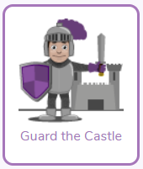Guard the castle (Chimp) - Help the night guard the castle  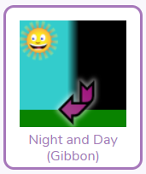Night and day (Gibbon)– Use variables, timers, and if statements to loop between night and day scenes.  TIP: Use the videos and hint section if you get stuck!  Topic -  Romans:  2do- Use the mashcam to turn yourself into Boudicca and explain why you attacked the Romans.  This video might help  https://www.youtube.com/watch?v=ZKqx7lvlQK0  Mrs Boerder had a go but I’m sure you can do better!  Science:  2do- Use what you have learnt about sound to create a leaflet. You can watch the slideshow again to help you.  Daily Times Tables:  Times tables  Multiplication 2do! Are you improving each week?  Please remember to try your best and have a go at the activities. Please don’t feel pressured or anxious about completing all tasks as we are well aware that home-life does not look the same in every house.
Class Dojo | Wellbeing Task - Pebble Path of positivity  - Paint/ Decorate your own pebble  - You can bring your pebble to school and place it outside the school with other children’s pebbles  - This will create a path of positivity into school.  - Design your pebble any way you want – using any colours or styles of decoration.  Send a picture to your teacher  Creative Task - Create your own Celtic Roundhouse  These video shows you what they were like https://www.bbc.co.uk/bitesize/clips/zqxtsbk  - The Celts lived in roundhouses before the Romans arrived  - Do the reading activity on roundhouses below first  - You can try to make one with twigs and things found in your garden  - If you don’t have any materials you could make a paper one  Send your teacher a picture!
Reading | Chapter 4 of these books has been set as a 2do. Choose one to read. Emerald Sapphire Treasure’s Island A Horde of Ravens Complete the online multiple-choice quiz for your chosen book. Read First News or a different newspaper. You can do this online if you don’t have one in the house.  Listen and read along to the story Krindlekrax, read by Mr Findlater on Flipgrid. Can you go through the first 3 chapters? Access the story here: https://flipgrid.com/98c4e191 Password: Storytime The reading challenges have changed slightly this week! The first 2 have been set as 2dos on Purple Mash, which means that we would like you to make sure you have completed them. You can then see how many of the other challenges you can complete. Read this no fiction article on Celtic Roundhouses http://www.primaryhomeworkhelp.co.uk/celts/index.html Follow these instructions on how they made them http://www.bbc.co.uk/history/interactive/animations/ironage_roundhouse/index.shtml  After you have listened to Krindlekrax make a prediction of what you think will happen next in the story. What will happen to Ruskin? What will Elvis do? Any other things you think will happen? Vocabulary is very important! If there are any words in Krindlekrax that you do not know. Pause the video and look them up in a dictionary or online. Write each word to a new sentence Use this link to have a go at the BBC Bitesize daily lesson on summarising: https://www.bbc.co.uk/bitesize/articles/zr93bdm The poems are about funny things that happen at school – I love reading these!

