Working from home Year Group overview
Year Group: 4
Week Beginning: 22.6.2020
Overview:
Teacher to plan: | Focus: | Task: | Deadline: | To be marked- yes or no
Miss Hardy | Maths | Times tables  This is Multiplication 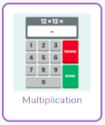  Maths: Focus – Time  This week we are learning about money and giving change from £1  There are 4 levels to master this week!  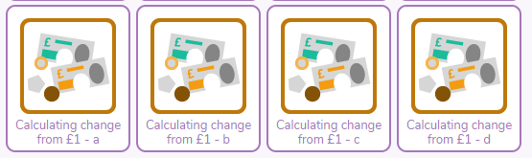 | Friday 26th June | Brief comment/  symbol
 | Topic | Purple Mash -  Romans:  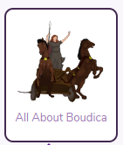2do- Apply all your knowledge of Boudica and The Celts to create an information booklet. If you click on the More+ button you are provided with some information. You can also use Google or YouTube to discover your own facts!  Science:  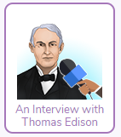 2do- Become a news reporter and create your own interview with Thomas Edison! | Friday 26th June | Yes
 | Computing | Purple Mash – Coding,  Rockets(Chimp) - Use timers and clicks to launch your rocket fireworks.  Catherine Wheel (Gibbon)– Use timers and variables to make your catherine wheel. | Friday 26th June | Brief comment/  symbol
Mr Findlater | Well Being - DOJO | Virtual P.E  With it being the time of year we would normally have Wimbeldon - this week’s well being activity is virtual P.E!  Look out for a post on Dojo on Thursday 18th and Friday 19th June | Chn not expected to spend more than 1 hour on this. | No- but children are encouraged to share a photograph with their teacher.
 | Creative Task - DOJO | Coin Art  Following from studying money in Maths, you’re going to use some of your coins at home to make art.  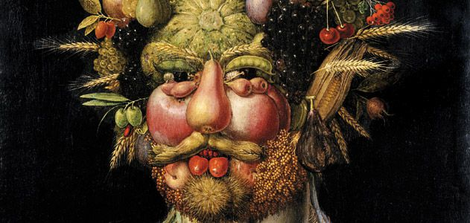  - Arcimboldo was an Italian Painter who became famous drawing pictures of faces using fruits and vegetables  - You are going to try and draw someone (could be yourself) but instead of fruit you will use coins.  - Use can use different coins for different parts of the face.  - Put the coins under the paper and colour over it to give your picture a textured coin effect.  Follow this video to help you with the technique - https://www.youtube.com/watch?v=0GLdbpqqNBs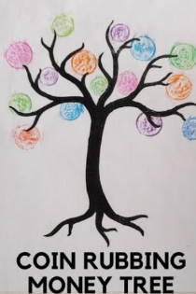 | Chn not expected to spend more than 1 hour on this. | No- but children are encouraged to share a video with their teacher.
Mrs Boerder | Reading Focus: Prepare a ‘reading challenge/interesting task or competition for the week.  Read an extract/story and upload to dojo.  Signpost to read First News weekly | Challenge:  Chapter 5 of these books has been set as a 2do. Choose one to read. Emerald Sapphire Treasure’s Island A Horde of Ravens Complete the online multiple-choice quiz for your chosen book. Read First News or a different newspaper. You can do this online if you don’t have one in the house.  These stories are getting close to the end! Can you predict the ending for the story that you have been reading? The first 2 reading challenges have been set as 2dos on Purple Mash, which means that we would like you to make sure you have completed them. You can then see how many of the other challenges you can complete. Non – fiction WITH YOUR ADULT’S PERMISSION, read and follow the instructions to perform one of these experiments. https://www.iop.org/education/teacher/extra_resources/stem/file_60284.pdf There are over 80 experiments to choose from!  Depending on the story you have read on Serial Mash, complete one of these activities. You can find them in your 2do list. Have a go at the animal quiz in the video by the author of ‘Charlie Changes into a Chicken’. https://www.youtube.com/watch?v=DKPWS2hZlWU&feature=youtu.be The quiz starts at 2:50 on the timer. Use this link to have a go at the BBC Bitesize daily lesson on choosing words to create humour: https://www.bbc.co.uk/bitesize/articles/zrcnf4j The text is a funny text – it should give you a laugh! | Ongoing through the week. | Some- the first 2 brief comment or symbol –children should be encouraged to respond to the other challenges via dojo.

Year 4 Week beginning 15.6.2020
Hello everybody. We would like the children to complete 5 tasks per week as well as Reading daily, and these can be carried out on the day/times that suit you. We have split the tasks between Purple Mash and Class Dojo. We are here to support you and your child – If you have any questions, queries or feedback, please do not hesitate to get in touch. Have a great week!
Purple Mash | Maths, computing and topic tasks have been set as ‘To dos’  Maths: Focus – Time  This week we are learning about money and giving change from £1  There are 4 levels to master this week!  Coding,  Rockets(Chimp) - Use timers and clicks to launch your rocket fireworks.  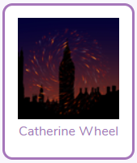Catherine Wheel (Gibbon)– Use timers and variables to make your catherine wheel.  Topic -  Romans:  2do- Apply all your knowledge of Boudica and The Celts to create an information booklet. If you click on the More+ button you are provided with some information. You can also use Google or YouTube to discover your own facts!  Science:  2do- Become a news reporter and create your own interview with Thomas Edison! There is a 2do full of information about him for you to read first.  Daily Times Tables:  Times tables  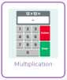Multiplication 2do! Are you improving each week?  Please remember to try your best and have a go at the activities. Please don’t feel pressured or anxious about completing all tasks as we are well aware that home-life does not look the same in every house.
Class Dojo | Wellbeing Task –Virtual P.E.  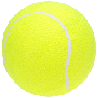Normally the Wimbledon tennis tournament would be happening at this time of year, so this week’s well-being activity is virtual P.E! 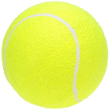  Look out for a post on Dojo on Thursday 18th and Friday 19th June!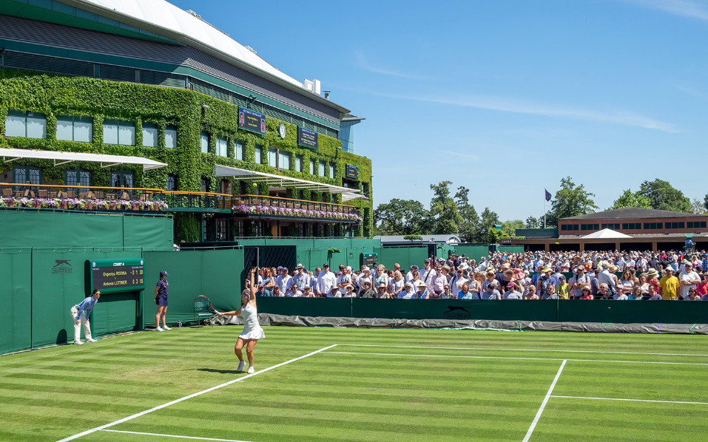  Creative Task – Coin Rubbing  Following from studying money in Maths. You’re going to use some of your coins at home to make art.  - Arcimboldo was an Italian Painter who became famous drawing pictures of faces using fruits and vegetables  - You are going to try and draw someone (could be yourself) but instead of fruit you will use coins.  - Use can use different coins for different parts of the face.  - Put the coins under the paper and colour over it to give your picture a textured coin effect.  Follow this video to help you with the technique - https://www.youtube.com/watch?v=0GLdbpqqNBs
Reading | Chapter 5 of these books has been set as a 2do. Choose one to read. Emerald Sapphire Treasure’s Island A Horde of Ravens Complete the online multiple-choice quiz for your chosen book. Read First News or a different newspaper. You can do this online if you don’t have one in the house.  These stories are getting close to the end! Can you predict the ending for the story that you have been reading? The first 2 reading challenges have been set as 2dos on Purple Mash, which means that we would like you to make sure you have completed them. You can then see how many of the other challenges you can complete. Non – fiction WITH YOUR ADULT’S PERMISSION, read and follow the instructions to perform one of these experiments. https://www.iop.org/education/teacher/extra_resources/stem/file_60284.pdf There are over 80 experiments to choose from!  Depending on the story you have read on Serial Mash, complete one of these activities. You can find them in your 2do list. Have a go at the animal quiz in the video by the author of ‘Charlie Changes into a Chicken’. https://www.youtube.com/watch?v=DKPWS2hZlWU&feature=youtu.be The quiz starts at 2:50 on the timer. Use this link to have a go at the BBC Bitesize daily lesson on choosing words to create humour: https://www.bbc.co.uk/bitesize/articles/zrcnf4j The text is a funny text – it should give you a laugh!

