New Knowledge Based Home Learning Activities
Good morning everyone ☺
Here are some new and exciting home learning tasks for you to do this week.
- There is a sheet of key facts for maths on adding and subtracting money to read.
- There is also a sheet of key facts on Boudicca to read.
Then, after you have read the knowledge sheets, we would like you to have a go at two Kahoot! quizzes on what you have learnt. These are great fun and you do them on your laptop, tablet or phone. Here are instructions on how to play:
- Google kahoot.it and click on the link below.
- Enter the Game PIN number
Maths: 010828
Boudicca: 323939

- Join the game by entering your first name (no nicknames please!) and pressing ‘OK, go!’

- Your teacher will be able to see who has played the quiz and your scores so make sure you have a go and try your best!
Reading
- We have also set some new books on Serial Mash. Read the first chapter of these and complete the quiz. Read Sapphire for more of a challenge.
Emerald | Sapphire
- Keep up to date with all of the interesting things that are happening in the world by following First News.
TT Rockstars
As well as all the fantastic reading you will do please remember to go on TT Rockstars. Your times tables are so important for your development and progress in Year 6 (If you can’t access these contact your teacher for a username and password)
There are also two spelling activities to have a go at (further down the page), and a quiz on these which has been set as a ‘to do’ on Purple Mash.
This way, we will be able to see how well you are doing on the quizzes!
Happy quizzing!
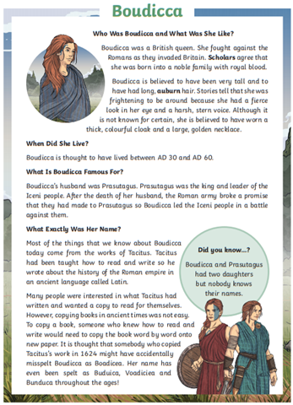

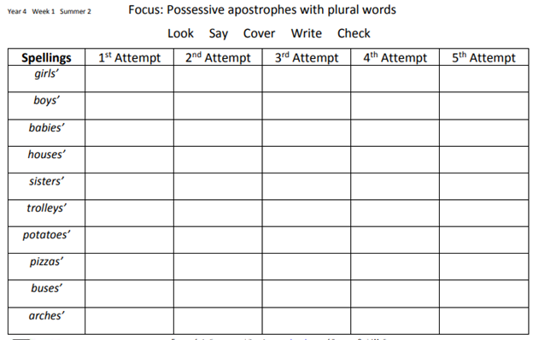
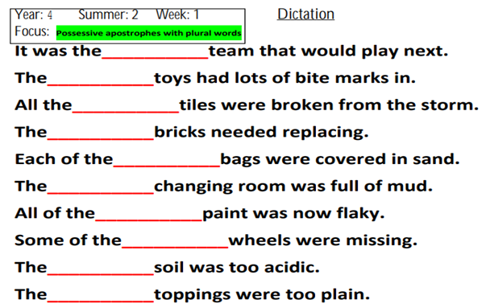

Answers on the next page!

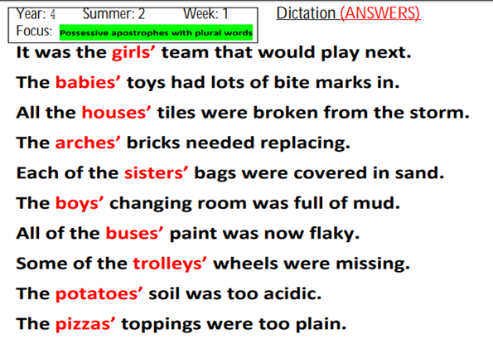
Maths
To add money:
- Put the numbers in a vertical column, aligning the decimal points
- Add each column of digits, starting on the right and working left. If the sum of a column is more than ten, "carry" digits to the next column on the left.
- Place the decimal point in the answer directly below the decimal points in the terms.
To subtract money:
- Put the numbers in a vertical column, aligning the decimal points.
- Subtract each column, starting on the right and working left. If the digit being subtracted in a column is larger than the digit above it, "borrow" a digit from the next column to the left.
- Place the decimal point in the answer directly below the decimal points in the terms.
- Check your answer by adding the result to the number subtracted. The sum should equal the first number.
