New Knowledge Based Home Learning Activities
Good morning everyone ☺
Here are the learning tasks for you to do this week.
- There is a sheet of key facts for maths on describing co-ordinates to read.
- There is also a sheet of key facts on Hadrian’s Wall to read.
- There is a creative task also for you to do.
Then, after you have read the knowledge sheets, we would like you to have a go at two Kahoot! quizzes on what you have learnt. These are great fun and you do them on your laptop, tablet or phone. Here are instructions on how to play:
- Google kahoot.it and click on the link below.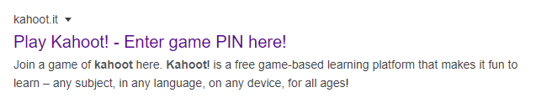
- Enter the Game PIN number
Maths: 0185913
Hadrian’s Wall : 02213482

- Join the game by entering your first name (no nicknames please!) and pressing ‘OK, go!’

- Your teacher will be able to see who has played the quiz and your scores so make sure you have a go and try your best!
Reading
- We have also set some new books on Serial Mash. Read the second chapter of these and complete the quiz. Read Sapphire for more of a challenge.
Emerald | Sapphire
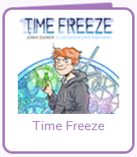 | 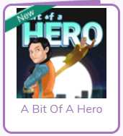
- Keep up to date with all of the interesting things that are happening in the world by following First News.
TT Rockstars
As well as all the fantastic reading you will do please remember to go on TT Rockstars. Your times tables are so important for your development and progress in Year 6 (If you can’t access these contact your teacher for a username and password)
There are also two spelling activities to have a go at (further down the page), and a quiz on these which has been set as a ‘to do’ on Purple Mash.
This way, we will be able to see how well you are doing on the quizzes!
Happy quizzing!

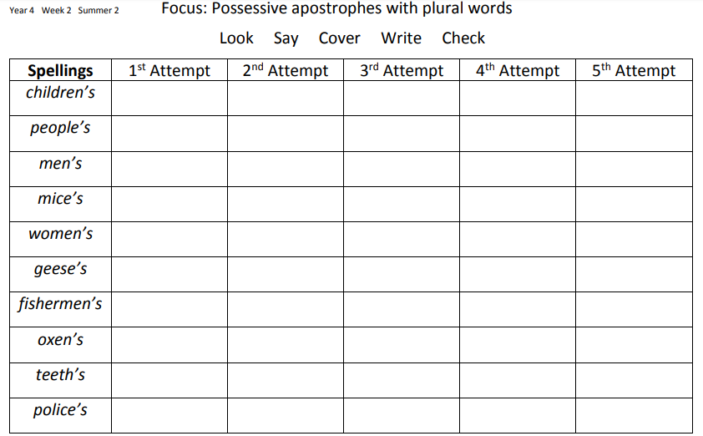

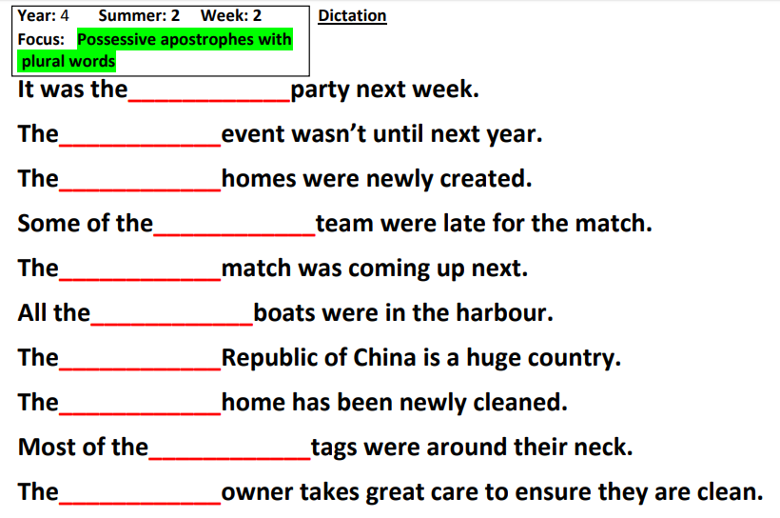

Answers on the next page!

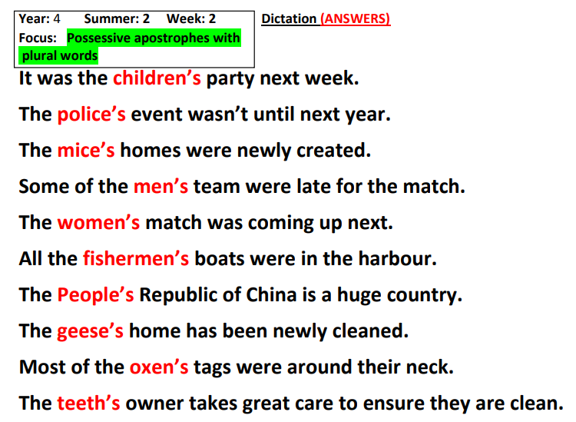
Maths
Describing Co-ordinates
Grids are a way of showing information. They are square.
We normally use 2 sides of the grid to describe where a co-ordinate is, these are the Axes.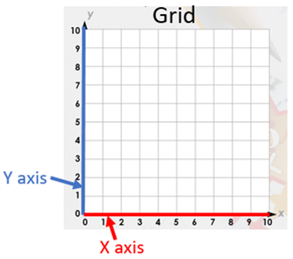
X Axis
The first axis is the X axis. This runs along the bottom of the grid. This has numbers along the bottom at equal spaces. In our examples they will go from 0 -10.
Y Axis
The Y axis runs up the side of the grid. This also has numbers at equal spaces.
Numbers
The co-ordinates tell us the place on the grid. They are 2 numbers inside brackets.
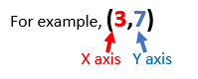
Left number = X axis
Right number = Y axis.
A way to remember this is ‘Along the corridor and up the stairs’
Look for the first number on the X axis then follow the line up the grid. Do the same with the Y axis number, where the lines cross is your co-ordinate.
Our example is 3 along the X axis and 7 up the Y axis. The co-ordinate is where their lines cross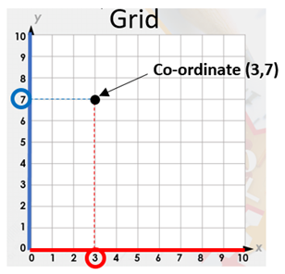

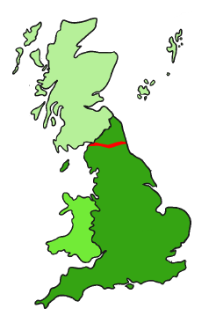
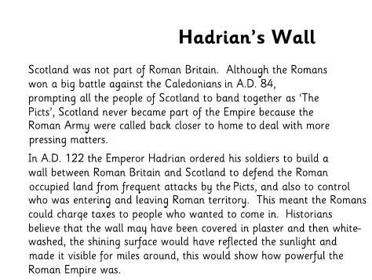

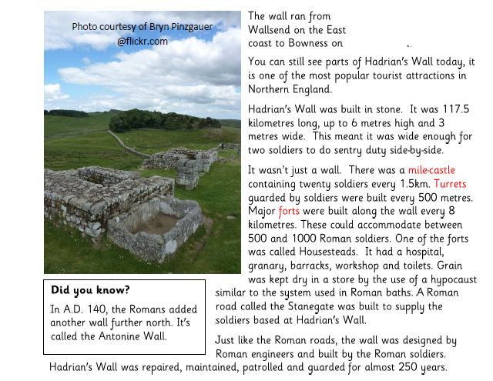

Creative Task- This week you creative task is to help our nature! Using recycled materials from around your house, you could create one of the following, or all!

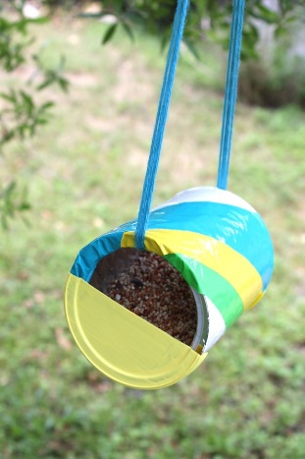
This idea uses an old, clean tin and duck tape to decorate. Be careful if you choose this example, and work with an adult as tins are very shape once they’ve been opened.

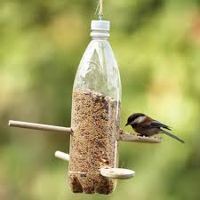
This is another great but simple idea. Take an old pop bottle, poke holes through and slide in a wooden spoon, or something similar for the bird to perch on!

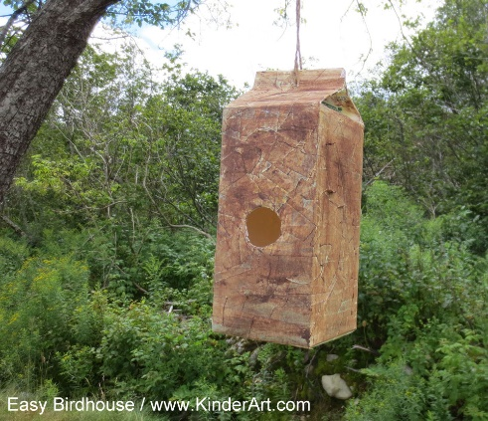

If you would rather make a birdhouse, all you need is a clean juice carton! Simply cut out a whole on the front and hang in a tree- decorate how you wish!

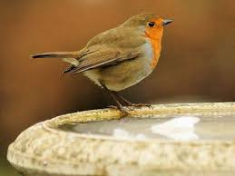
If you would like to challenge yourself further, you could make a birdbath! All you need is a bowl of some sort, and a something to raise it off the floor! Then fill with water and watch and wait!

